**U.S. Department of Veterans Affairs (VA)**

**Office of Public and Intergovernmental Affairs (OPIA)**

**Strategic Outreach Support Services (SOSS)**

**Contract Number: GS-23F-0137R**

**Digital Outreach Campaign**

**Final Report**

**September 27, 2016**

# Overview

On September 28, 2015, Schatz Strategy Group resumed the ExploreVA digital outreach campaign, which experienced a 3 month gap between contractors. Work performed under this contract supported the U.S. Department of Veterans Affairs (VA) Office of Public and Intergovernmental Affairs (OPIA). The purpose of the campaign is to promote the Department’s [ExploreVA website](http://explore.va.gov/), the cornerstone of the campaign developed in 2013 to help the Nation’s 22 million Veterans and their families learn about and apply for VA benefits and services. The website features explanations of VA benefits, eligibility and application processes in easy-to-understand language, a self-guided Benefits Navigator tool, and other resources to help Veterans, Servicemembers and their families learn about the VA benefits they have earned through their service.

Schatz continued to utilize strategies mapped out in the first two years of the campaign, building upon established best practices while recommending new strategies to increase campaign effectiveness. The overall campaign strategy centered on monthly themes highlighting one or more of the nine VA benefit areas.

Campaign activity was divided into five functional areas: website maintenance and design; paid media; email marketing; social media and digital events; and partner outreach. The purpose of this year-end report is to provide an analysis of activities completed in Fiscal Year 2016 (FY 2016), highlight noteworthy achievements, and provide recommendations for improving future campaign activities. This report includes an analysis of all campaign activities between September 28, 2015 and September 15, 2016.[1],[2]

### Highlights

A complete listing of highlights for each function area is shown in this report. Overall highlights and takeaways from the reporting period include:

* The ExploreVA website had over 1.3 million visits – 76 percent of which were new visitors to the site.
* There were 385,904 benefit application starts (“applies”) initiated on the ExploreVA website. Of those, 14.4 percent (55,485) resulted from paid keyword search.
* There Benefits Navigator tool was completed 30,536 times by visitors to the site.
* In July 2015 the previous paid campaign flight concluded with an overall CPA of $9.52. As of September 15, 2016, we were able to reduce this by 7 percent through continuous optimization and monitoring to an overall CPA of $8.89.
* The Paid Keyword Search tactic drove the largest number of sessions (201,297), while Video resulted in a 92% conversion rate.
* Emails performed exceptionally well throughout the campaign, delivering open rates ranging from 26 to 42 percent and consistently outperforming other public email campaigns and Veteran-focused campaigns.

### Recommendations

Based on an analysis of these details, Schatz offers the following recommendations for moving forward with the ExploreVA campaign:

* **Identify new site features to test, and continue to optimize the site for mobile visitors.** More information and additional recommendations in the area of website design provided here.
* **Continue to utilize Paid Keyword Search, Remarketing, and Video Ads.** A complete list of highlights and recommendations for paid media can be found here.
* **Continue to test and utilize new and emerging technologies (e.g., Facebook Live, Facebook Events) for monthly digital events.** Additional recommendations for social media and digital events are provided here.
* **Continuously test subject lines, calls-to-action (CTAs), and email release days/times for optimal performance.** Additional recommendations for email marketing are provided here.
* **Engage the internal VA community in promoting ExploreVA, and establish a clearly defined process for external outreach.** Additional partner engagement recommendations are provided here.

# Outreach Strategy

The outreach strategy for the ExploreVA digital campaign was at the core of the strategic plan to ensure that Veterans, Servicemembers and their family members were informed about VA benefits and services, and their potential eligibility, based on their service. This integrated campaign strategy included efforts in five key functional areas; website design and support, paid media, email marketing, social media and digital outreach, and partner engagement.

## Website Management

Schatz provided website design, testing and support to continuously improve the ExploreVA website throughout the year. This work included making periodical content updates, conducting monthly A|B testing, optimizing for mobile users, and installing new functionality and features to improve the overall user experience.

Noteworthy highlights and updates to the ExploreVA website completed in FY 2016 include:

* **ExploreVA outperforms other websites in the Veteran-focused and Law and Government categories in terms of overall traffic, new visitors and bounce rates.** New visitors to ExploreVA (77 percent) outperforms industry standards for Veteran-focused (68 percent) and Law and Government (60 percent). With an exceptional 35 percent bounce rate, ExploreVA also significantly outperforms both categories (51 percent and 54 percent, respectively).
* **Addition of “Share This Page” functionality to Events page facilitates easier sharing of events on social media.** The addition of this feature to the Events page had a significant impact on the number of individuals sharing information about the digital events with their Facebook and Twitter networks.
* **Light windows on related benefit subpage(s) positively impact event registrations.** The light window featured on the Life Insurance subpage leading up to the May 2016 digital event resulted in 28 percent more registrations for the event.
* **Including a call-to-action (CTA) on the event register confirmation light window drives engaged site visitors to additional pages on ExploreVA.** Encouraging event registrants to visit other pages related to the event they just signed up for can increase average pageviews and time on site for these visitors.

### Audience Analysis

An audience analysis of the ExploreVA website reveals the following key takeaways:

* There were more than 1.3 million website visitors, 76 percent being new visitors and 23.5 percent being return visitors.
* Visitors to ExploreVA spend an average of 2 minutes, 16 seconds on the site and view 2.49 pages per session.
* ExploreVA’s overall 33.5 percent bounce rate is 31 percent lower than other Veteran-focused websites and 35 percent lower than other Law and Government websites. In addition, the bounce rate also outperforms most websites whose bounce rates are typically in the 41-55 percent range.
* While most visitors (58 percent) are accessing the site from a desktop, it’s worth noting that mobile visitors saw a 27 percent increase from December 2015 to August 2016. This trend should be expected with more and more consumers owning smartphones and tablets.

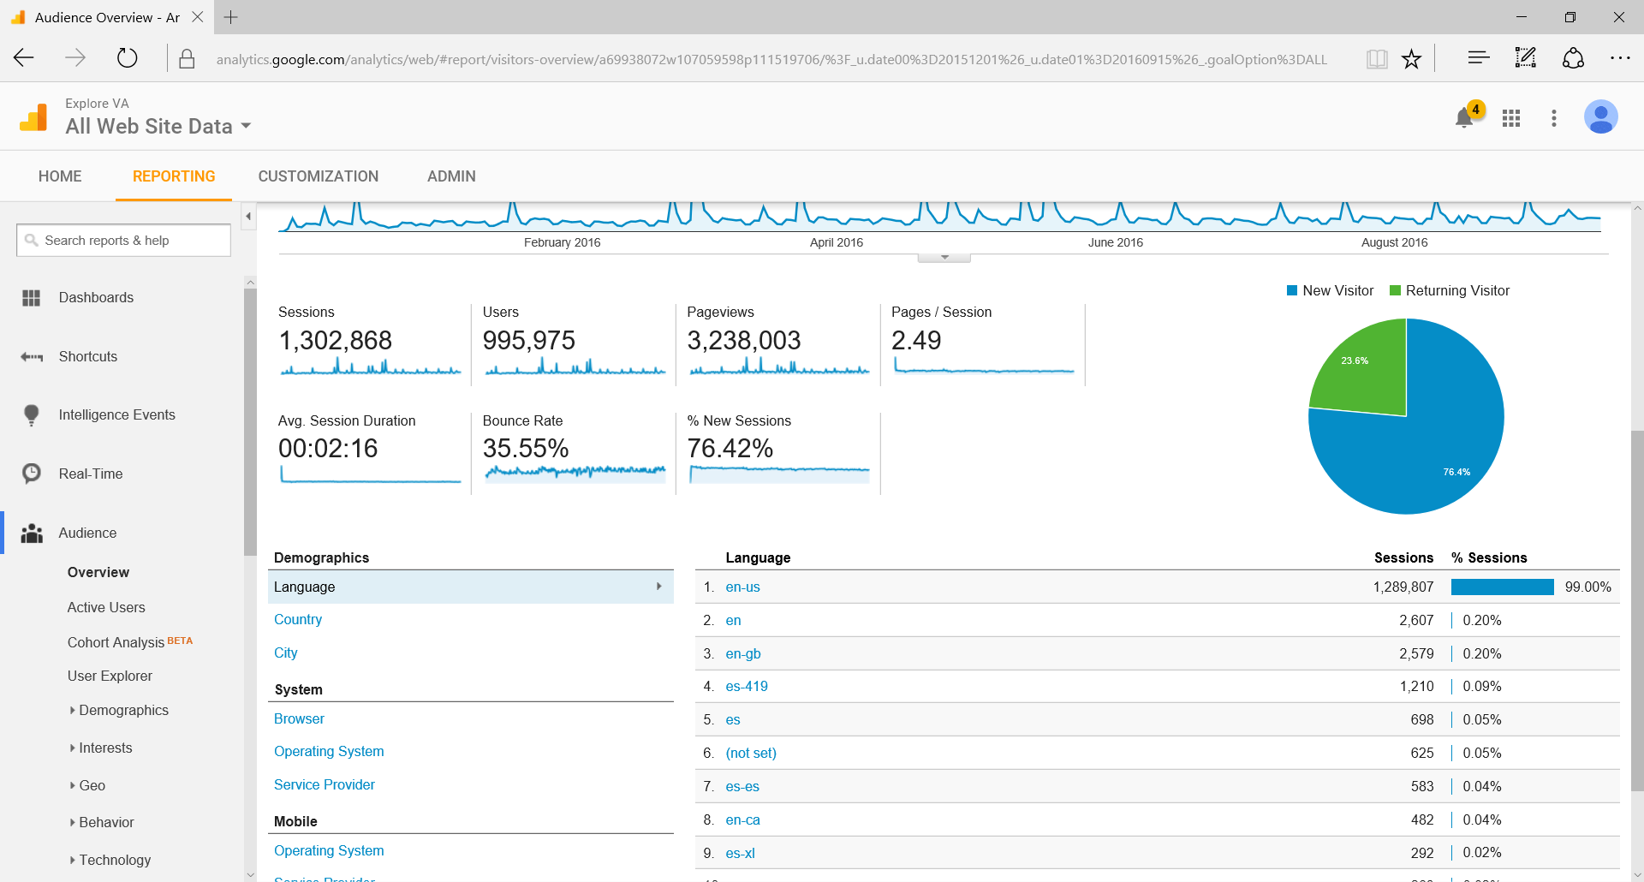

Figure – New vs. Returning Visitors

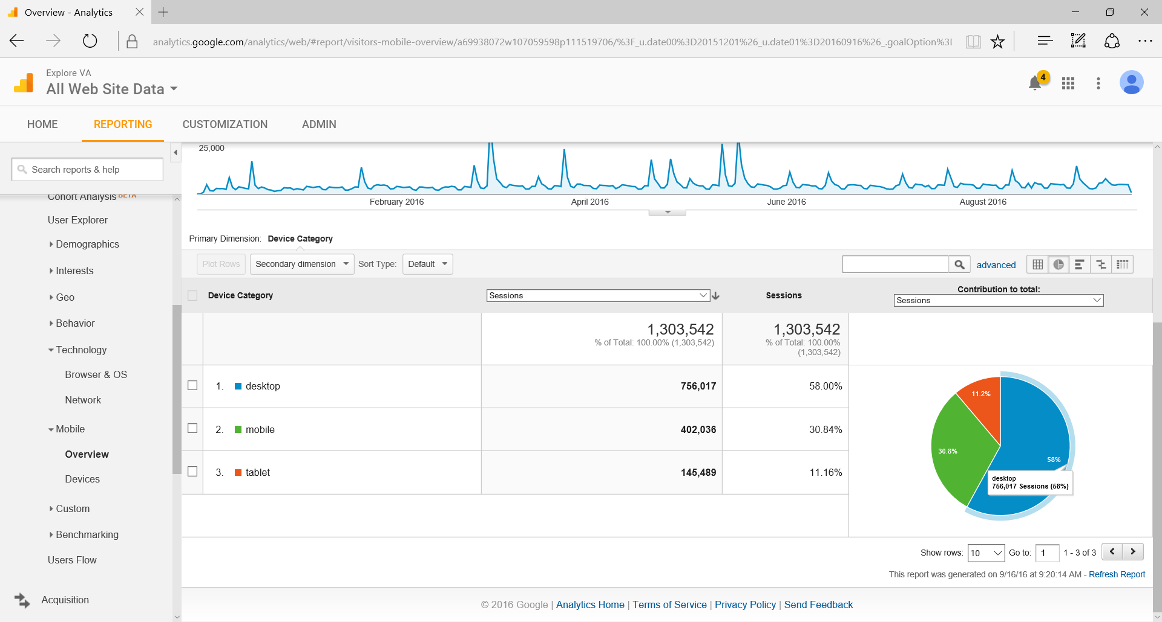

Figure – Site Traffic by Device

### Acquisition Analysis

An analysis of sources driving traffic to the ExploreVA website reveals the following key takeaways:

* Paid Keyword Search drove more than 200,000 visits, 33.6 percent of all visits compared to other tactics.
* Search Remarketing drove the second-highest number of visits, recording more than 46,000 visits during the reporting period.
* Referrals from other websites resulted in the highest visit duration and pages viewed per session.
* Email was a significant driver of traffic throughout the campaign period, with the May 17th Life Insurance email driving the highest number of visits (45,203), followed closely by the March 1st Memorial Benefits email.

Figure - 12-Month Traffic Breakdown by Source

### Behavior Analysis

An analysis of actions taken by ExploreVA website visitors reveals the following key takeaways:

* The ExploreVA home page received the largest volume of pageviews (627,101).
* Benefit subpages receiving the largest volume of pageviews included Disability Compensation (187,721), Education and Training (170,274), and Health Care (163,014).
* The Events page received the 4th largest volume of pageviews (163,391).
* There were 386,216 total applies from the ExploreVA website, with Education and Training receiving the most applies (69,295) followed by Disability Compensation (49,177).
* Visitors accessing the website directly resulted in the most applies (52,882), followed by referrals from VA.gov (44,746) and Paid Keyword Search (37,266).

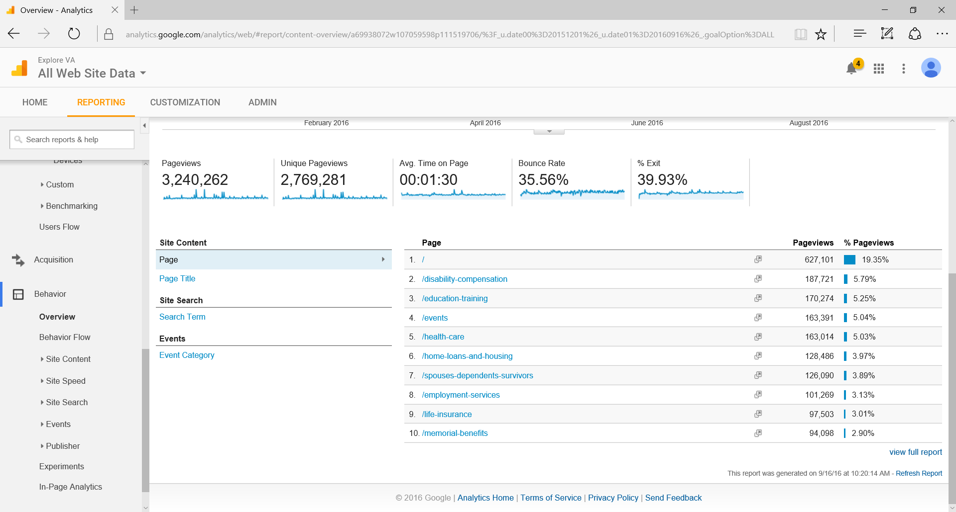

Figure - Top 10 Pages Accessed (by Pageviews)

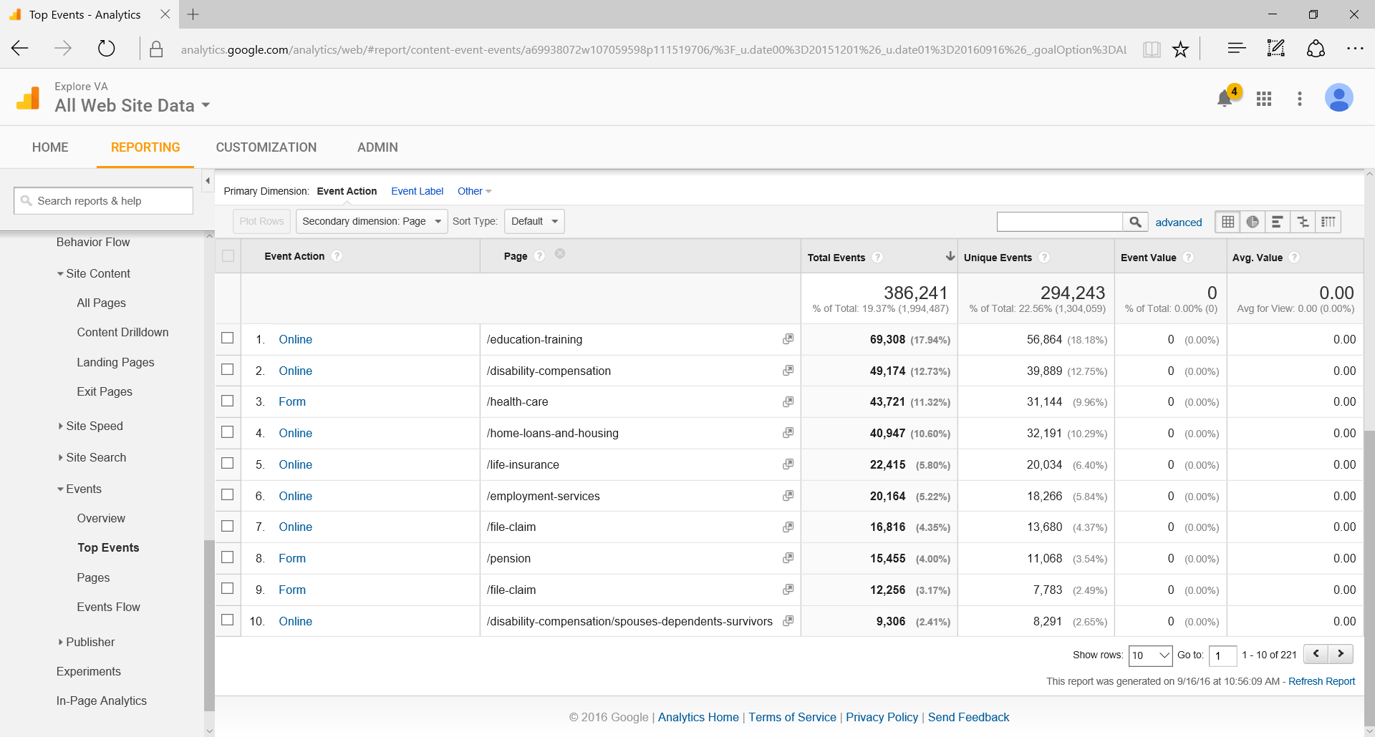

Figure - Top 10 Applies by Benefit Area

### Conversions Analysis

An analysis of on-site conversions reveals the following key takeaways:

* + - * + The ExploreVA home page resulted in the most applies (170,599) compared to all other landing pages.
        + There were 50,178 starts and 30,564 completions of the Benefit Navigator tool.

### A/B Test Analysis

In an effort to continuously improve the ExploreVA website, Schatz conducted monthly A|B testing beginning in January 2016. A summary of each test with results and recommendations can be found below in Table 1.

| Table 1 – Website A|B Testing | | |
| --- | --- | --- |
| Month | Test/Results | Recommendation |
| Jan. 2016 | * Included a prominently featured video on the event registration page * No impact on registration rate; increased time on page | * Feature video when possible |
| Feb. 2016 | * Included a more prominently featured CTA for the overview videos featured on the benefit pages * No impact on view rate | * Continue with original design |
| Mar. 2016 | * Added additional navigation to the bottom of subpages * No impact on time on site or pageviews | * Continue with original design |
| Apr. 2016 | * Included a light window promoting the digital event on related subpages * Noticeable increase in registrations; unable to verify with data due to Google Analytics tracking issue. | * Continue testing |
| May 2016 | * Tested headlines on light windows promoting digital events on related subpages (continuation of April test) * Resulted in 28 percent more event registrations | * Although registrations increased, applies may be sacrificed * Continue with original design per OPIA |
| June 2016 | * Tested varying CTAs on Benefits Navigator results page buttons * “Explore” CTA resulted in most clicks (39%), followed by “Learn More” (32%) and “Apply Now” (29%) | * Continue with original “Explore” CTA |
| July 2016 | * Included CTA/link to Health Care subpage on event register confirmation window * Resulted in 19% of registrants clicking through to subpage | * Continue testing with larger sample size |
| Aug. 2016 | * Included CTA/link to Vet Center subpage on event register confirmation window (continuation of July test) * Resulted in 19% of registrants clicking through to subpage | * Continue testing with visuals |
| Sept. 2016 | * Included CTA/link to home page on event register confirmation window (continuation of July test) | * Include CTA on confirmation window when possible |

### Insights and Recommendations

Based on an analysis of ExploreVA website data and A|B tests completed throughout the campaign, the following insights and recommendations can be used to further improve the website:

* **Continuously optimize the site for mobile visitors.** With mobile use continuing to increase, further testing and optimizations should be completed to improve overall user experience and drive more conversions.
* **Utilize event register confirmation windows to drive traffic to subpages related to the monthly digital events.** Planning for these light windows should be worked into the overall production timeline, as they do require coordination with the events.
* **Identify new ways to increase organic traffic from Events page to benefit subpages.** Additional features can be identified by monitoring behavior trends of visitors accessing the Events page.

## Paid Media

Following the approved strategies included in the Web-Based Outreach Plan and Digital Media Buy Plan, Schatz relaunched a nationwide paid online advertising campaign in December 2015. Since relaunching, Schatz was able to reduce the CPA—our primary measurement of success—by 7 percent. Before relaunching, we completed an initial analysis of historical data from previous campaign periods, identifying effective tactics, keywords, and ad creative used previously while recommending any improvements to our overall strategy.

Noteworthy highlights from the paid media campaign:

* + - * The overall CPA saw a 7 percent reduction over the course of the campaign flight**.** The final CPA of $9.52 in July 2015 was consistently reduced throughout FY 2016, ending with a CPA of $8.89.
      * The Paid Keyword Search tactic ended with a Click-thru-Rate of 5.08% (National Average 1.00% - 2.00%) and average position of 1.6. The Remarketing tactic ended with a CTR of 0.27% (National Average 0.10%) and the Video tactic ended with a View Rate of 19.63% and Retention Time of 87%.
      * The Paid Campaign saw a total of 252,287 sessions on site between December 9, 2015 and September 15, 2016. Between Paid Keyword Search, Remarketing, Audience, and Video tactics the campaign resulted in 63,250 applies and 46,422 email sign-ups.
      * The Search tactic drove 201,297 sessions between December 9, 2015 and September 15, 2016. This traffic resulted in 55,489 applies and 32,267 email sign-ups, a 44 percent conversion rate.
      * The Video tactic saw the highest conversion rate of 92% between March 4, 2016 and September 15, 2016. This tactic drove 705 sessions that resulted in 37 applies and 610 email sign-ups.
      * Texas, Florida, and California saw the highest amount of traffic to site from the Paid Keyword Search tactic.

An analysis of each paid media channel used throughout the FY 2016 campaign with recommendations for future campaign flights can be found in the following sections.

### Paid Keyword Search

This tactic was launched on December 9, 2015 and targeted an audience that was highly in-market for Veteran benefits. Keyword match types were continuously adjusted throughout the campaign flight to elevate top performing keywords while achieving the best possible CPA. Our findings showed that when serving to the U.S., narrowing the targeting through defined keyword match types helps to serve to the most relevant audience while receiving a lower cost, ultimately benefiting the campaign by allowing for the most efficient use of budget. An analysis of keywords, ad groups, and ad creative used throughout the campaign flight can be found below.

#### Keyword Analysis

An analysis of keywords reveals the following key takeaways:

* + - * + For the Education and Training ad group, the highest demand of all search terms was for “GI Bill”; this term resulted in 403,697 impressions and 22,575 clicks for an overall 5.50% click-thru-rate (CTR).
        + For the Disability ad group, the terms “VA Disability Payment” and “VA Disability Compensation” resulted in a total of 255,782 impressions and 15,676 clicks for an overall 6.13% CTR.
        + For the Health Care ad group, the term “VA Health Insurance Benefits” received one of the highest CTRs (9.42%) among all keywords. This term resulted in 76,210 impressions and 7,180 clicks.

#### Ad Group Analysis

An analysis of ad groups reveals the following key takeaways:

* + - * + The Employment, Health, Disability, and Education ad groups saw the highest demand in terms of search volume throughout the campaign flight. Budgets were shifted accordingly throughout the campaign flight to maximize these better performing categories.
        + Of the 63,250 applies resulting from the paid campaign, the top performing ad group in terms of applies was Employment (11,147 applies), followed closely by Health Care (10,101 applies), Disability (9,741 applies) and Education (8,144 applies).
        + Although the Veteran Burial, Spouse, and Dependent ad groups didn’t see a high demand throughout the campaign, they did perform exceptionally well in terms of CTRs when the ads were served, resulting in minimum CTRs of 6.8%.

#### Ad Creative Analysis

An analysis of ad creative reveals the following key takeaways:

* + - * + The generic ‘Explore VA Benefits’ ad directing users to the home page was the top performing ad throughout the campaign. This ad served 7.81 percent of the time—more than doubling the typical performance of good performing ads that are served around 3 percent of the time. Automatic optimizations made by the ad platform based on performance resulted in the ad variation below in Figure 5 being served the most, resulting in 385,517 impressions and 15,829 clicks for an overall 4.11% CTR.

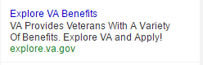

Figure - Top performing ad (Generic)

* + - * + The top performing ad in the Disability Compensation ad group was the mobile ‘VA Compensation Benefits’ ad. This ad resulted in 144,523 impressions and 12,433 clicks for an overall 8.60% CTR.

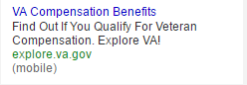

Figure - Top performing ad (Disability Compensation)

* + - * + For the Education and Training ad group, the top performing ad was the mobile ‘GI Bill Benefits’ ad. This correlates with “GI Bill” being the top performing keyword within this ad group. This ad resulted in 163,287 impressions and 12,375 clicks for an overall 3.31% CTR.

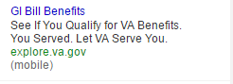

Figure - Top performing ad (Education and Training)

* + - * + A new set of ad creative was tested in August 2016 to determine if ad performance could be improved further. The test focused on new copy and layout with two new generic Home Page ads, two Home Loans ads, one Disability and Compensation ad, and one Education and Training ad. Our goal was to see if the different ad copy elements helped to improve results.

Our findings showed that the use of terms that directly speak to the searcher (i.e. ‘You’ or ‘Your’) and a variety of ad layouts performed consistently better than the original ads.

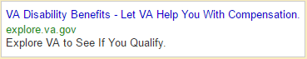

Figure - Sample new ad creative

### Remarketing

The Remarketing tactic was launched on December 14, 2015. This tactic targeted previous visitors of the ExploreVA website to drive them back to site. This tactic drove 47,963 visitors back to site and resulted in 7,719 applies and 13,152 email sign-ups between December 14, 2015 and September 15, 2016. The remarketing ads were viewed 15,870,370 times within this timeframe as well.

* + - * The Remarketing list held a consistent amount of approximately 300,000 users each month.
      * The top performing ad creative sizes were 300x250 and 728x90.
      * The top performing ad for the campaign was Pension 300x250 with 132,012 impressions and 626 clicks for an overall 0.47% CTR.

### Video Ads

The Video tactic was launched on March 4, 2016, and featured a [40-second video ad](https://www.youtube.com/watch?v=rakI6wRPBSw) consisting of clips from existing testimonial videos. Unlike the Paid Keyword Search and Remarketing tactics, this tactic was used to build brand awareness by targeting users in the Veteran and Military audience category that were not necessarily in-market at the moment for VA benefits. This type of targeting gave the campaign the opportunity to reach Veterans that were unfamiliar with the ExploreVA site, and to educate them with through the short video ad. This tactic received a total of 151,521 views with a retention rate of 87 percent, meaning that most viewers watched 87 percent of the video ad. These views resulted in 705 sessions on site, 37 applies, and 610 email sign-ups.

Figure - Sample display banner ad

* + - * This tactic received a phenomenal view rate of 19.63% throughout the campaign. The video ad was served 771,693 times and watched 151,521 times.
      * The retention rate, which is the average percent of the video watched, stayed at a consistent 86% throughout the entire campaign. The majority of viewers watched approximately 34 seconds of the 40-second video, which is approximately when the VA caption screen shows.
      * The Video tactic had a 1.03% CTR, resulting in 705 sessions on site. Of those sessions, 92 percent of visitors converted by either applying or signing up for email updates.

## Insights and Recommendations

Based on an analysis of ExploreVA paid campaign data, the following insights and recommendations can be used to further improve the future campaign flights:

* + - * **Continue pairing the Video tactic with Paid Keyword Search for optimal results.** The Video tactic is able to reach a new audience that might not be as familiar with ExploreVA.
      * **Continue using Remarketing to attract returning visitors.** With 75 percent of visitors being new to the site, a greater effort could be made to remind visitors to come back to the site to begin their benefit application process.
      * **Continue to monitor keywords and adjust bidding and match types to stay competitive.**
      * **Test varying ad copy, layouts, display ads and video ads throughout the campaign.** This will help prevent ad fatigue and keep online audiences engaged.
      * **Build upon success of Remarketing by extending these efforts into Remarketing Lists for Search Ads (RLSA).** This will serve search ads to users who have visited the ExploreVA site.
      * **Focus ad spends on securing placements between 7:00 a.m. ET and 5:00 p.m. ET.** Outside of these hours, the campaign still received excellent CTRs but fewer impressions and clicks.
      * **Consider developing keywords and ads focused on promoting digital events.** Dedicating a small portion of the monthly ad spend to focus solely on the digital event for that month may help drive a higher level of awareness and registrations.

## Social Media/Digital Events

The central component of the outreach strategy was the execution of monthly digital events in partnership with organizations that serve Veterans and their families. These events are part of a series called “#ExploreVA: From Service to Success” designed to increase awareness of ExploreVA and leverage two-way engagement opportunities to provide stakeholders with real-time customer service.

Schatz planned, developed, and executed monthly digital events on social media platforms including Facebook and Twitter, and one event on Memorial Benefits Pre-Need Applications that has yet to be approved for release by VA. The topic for each event was driven by a number of factors including current events, priorities set by OPIA, partner interest and Veteran needs.

Noteworthy highlights and takeaways from social media and digital events:

* **Successful piloting of Facebook’s new live streaming capabilities.** The August 2016 Vet Center Video Tour and Facebook Chat reached more than 150,000 people and resulted in over 30,000 video views, making this a viable option for future ExploreVA digital events.
* **More than 10,000 registered for the May 2016 Life Insurance Facebook Chat.** This event garnered the highest number of registrants, likely due to the time-sensitive application process.
* **More than 7,000 registered for the April 2016 Home Loans Facebook Chat.** This event garnered the second-highest number of registrants in large part due to the timing of the event coinciding with the start of home-buying season.
* **Twitter chats do not appear to be the best platform for digital events.** This platform was only utilized twice in FY 2016; both events had a significantly lower level of registrations and engagement. Facebook, a more widely used platform among ExploreVA target audiences, should be utilized whenever possible.

A summary of digital events completed throughout FY 2016 can be found below in Table 2. A full analysis of each event can be found in the wrap-up reports delivered to OPIA following each event.

| Table 2 – Monthly Digital Events | | | |
| --- | --- | --- | --- |
| Month | Event Topic/Format | Host(s) | Results |
| Dec. 2015 | * Employment Services Twitter Chat | * Hiring Our Heroes * Blue Star Families | * 647 registered * Total Reach: 377.5K * 445 tweets |
| Jan. 2016 | * Vet Center Counseling and Services Video Panel and Facebook Chat | * Team Red, White and Blue | * 3,024 registered * Total Reach: 14.8K * 422 video views |
| Feb. 2016 | * Memorial Benefits Facebook Chat | * Tragedy Assistance Program for Survivors | * 3,962 registered * Total Reach: 1.05M * 387 comments * 1.64K video views |
| Mar. 2016 | * VA Serves Women Veterans Facebook Chat | * Veterans of Foreign Wars | * 2,384 registered * Total Reach: 94.5K * 350 comments |
| Apr. 2016 | * Home Loans Facebook Chat | * National Association of Realtors | * 7,398 registered * Total Reach: 98.2K * 469 comments * 1.5K video views |
| May 2016 | * Life Insurance Facebook Chat | * Institute for Veterans and Military Families | * 10,489 registered * Total Reach: 102K * 533 comments |
| June 2016 | * Education and Training Facebook Chat | * Team Rubicon | * 2,344 registered * Total Reach: 113K * 283 comments |
| July 2016 | * Diabetes Prevention and Care Twitter Chat | * Disabled American Veterans | * 2,009 registered * Total Reach: 524.4K |
| Aug. 2016 | * Vet Center Video Tour and Facebook Chat | * Veterans of Foreign Wars | * 3,069 registered * Total Reach: 151.8K * 30K+ video views |
| Sept. 2016 | * Suicide Prevention for #WomenVets Facebook Chat | * American Women Veterans | * 759 registered * Total Reach: 76.7k |

### Insights and Recommendations

Based on an analysis of ExploreVA social media and digital event activities completed in FY 2016, the following insights and recommendations are being made:

* **Continue to utilize new and emerging technologies for digital events.** An initial pilot of Facebook’s new live streaming capabilities yielded positive results. This platform should be used for future event topics lending themselves to video. We also recommend piloting the use of Facebook events for future chats on this platform. Facebook events can allow for automated reminders released by the platform, and a more organized event that can be more easily navigated and managed by both participants and VA SMEs. This format was also suggested by multiple partners in FY 2016.
* **Increase volume and frequency of posts promoting digital events from VA social media accounts, and improve communication and coordination between all parties.** Several partners asked during our event promotion outreach efforts if VA had posted anything related to the event that they could simply share. It is never too early to start promoting an event, and the best way to get traction and visibility among partners we may not reach by phone or email, but are following VA on social media, is to share the event on VA social media early and often. VA social media properties should also be sure to share the event post to increase reach.
* **Provide SMEs with tutorials on digital event participation prior to the event.** VA SMEs were often confused as to how to participate and navigate around the platform during the event, oftentimes creating a distraction from answering participant questions. Sharing tutorials with tips and tricks for navigating Facebook, Twitter, etc. can likely alleviate a lot of this confusion.
* **Develop an archive of digital events on the ExploreVA website.** Creating an archive for ExploreVA visitors to peruse at their leisure will help extend the reach of the digital events.
* **Digital events themselves do not appear to be a significant driver of ExploreVA site traffic.** However, promotional activities surrounding the events (e.g., registration emails) consistently drive large volumes of traffic. As such, additional ways to drive these visitors to other pages on ExploreVA should be continuously identified and tested.

## Email Marketing

In addition to paid media, Schatz leveraged an ever-growing list of subscribers to email updates from VA to drive an average of 32,185 monthly visits to ExploreVA via email marketing. Using the GovDelivery platform, Schatz released three HTML emails promoting digital events and monthly benefits to more than 1.2 million subscribers to the VA Updates list, and maintained an editorial calendar with monthly topics, release dates and development schedules for emails through the end of the contract.

Noteworthy highlights and takeaways from email marketing:

* **Email open rates were consistently higher than industry averages.**[3]ExploreVA open rates averaged 35 percent—much higher than GovDelivery’s reported rates for the Top 20% for “overall” (31 percent) and “federal” categories (22 percent).
* **When comparing open rates and click rates to the Defense and Veteran Affairs sector, ExploreVA emails perform significantly better in both areas.** ExploreVA’s CTRs ranged from 1.80-3.01 percent.
* **The Memorial Benefits and Veterans Day benefit-focused emails had significantly higher levels of engagement than other benefit emails.** Both emails had open rates higher than 40 percent and unique CTRs higher than 4 percent.
* **An ExploreVA email was offered as an example of a well-crafted HTML email in GovDelivery’s 2016 email benchmark report.** The report can be accessed via GovDelivery.

### Topics and Performance Analysis

Topics for each of the monthly benefit-focused emails were selected to align with topics for the monthly digital events or current events. A listing of monthly topics for the benefit-focused emails with high-level performance metrics can be found below in Table 5.

|  |  |  |  |
| --- | --- | --- | --- |
| Table 3 – Monthly Benefit Emails | | | |
| Month | Email Topic | Open Rate | Unique CTR |
| Nov. 2015 | * Veterans Day | * 41.7% | * 4.6% |
| Dec. 2015 | * Employment Services | * 32.0% | * 1.8% |
| Feb. 2016 | * Memorial Benefits | * 45.9% | * 4.80% |
| Mar. 2016 | * Vietnam 50th Commemoration | * 30.4% | * 2.30% |
| Apr. 2016 | * Home Loans | * 34.4% | * 1.70% |
| May 2016 | * Life Insurance | * 31.9% | * 3.30% |
| June 2016 | * Education and Training | * 35.2% | * 1.70% |
| July 2016 | * Health Care | * 30.3% | * 1.25% |
| Aug. 2016 | * Vet Centers/Health Care | * 32.7% | * 1.09% |
| Sept. 2016 | * Suicide Prevention | * 24.4% | * 0.49% |

A listing of ExploreVA digital event registration emails with high-level performance metrics can be found below in Table 6.

|  |  |  |  |
| --- | --- | --- | --- |
| Table 4 – Digital Event Registration Emails | | | |
| Month | Registration Email | Open Rate | Unique CTR |
| Dec. 2015 | * Employment Services Twitter Chat | * 26.7% | * 0.70% |
| Feb. 2016 | * Memorial Benefits Facebook Chat | * 32.0% | * 1.40% |
| Mar. 2016 | * VA Serves Women Veterans Facebook Chat | * 33.4% | * 0.80% |
| Apr. 2016 | * Home Loans Facebook Chat | * 40.7% | * 1.60% |
| May 2016 | * Life Insurance Facebook Chat | * 34.9% | * 2.40% |
| June 2016 | * Education and Training Facebook Chat | * 30.3% | * 1.10% |
| July 2016 | * Diabetes Prevention and Care Twitter Chat | * 31.3% | * 1.00% |
| Aug. 2016 | * Vet Centers Video Tour and Facebook Chat | * 37.9% | * 0.96% |
| Sept. 2016 | * Suicide Prevention Facebook Chat | * 27.5% | * 0.39% |

### Insights and Recommendations

Based on an analysis of ExploreVA email activity in FY 2016, the following insights and recommendations can be used to further improve future email efforts:

* **A|B test subject lines and delivery days/times for optimal results.** Build in time for testing subject lines prior to the full release, preferably on the same day and time one week prior to the scheduled release date.
* **Continue testing timing of the event reminder emails.** Our research shows that emails released at 12:00 p.m. ET typically perform the best. This timing should be targeted while other days and times are tested occasionally.

## Partner Engagement

Throughout the campaign Schatz established and managed relationships with partner organizations including Veteran service organizations (VSOs), community-based organizations (CBOs), and non-traditional partners with interests aligned with VA (e.g., employers, brokers). Schatz maintained a master partner outreach database containing over 1,400 state and national points of contact (POCs). Each month Schatz identified target organizations whose interests aligned closely with the featured monthly benefit(s) and prioritized contacting these organizations directly.

Normal monthly outreach to POCs at partner organizations included the following:

* **An initial email promoting the monthly digital event.** The email included the event details, a link to the landing page, instructions for using the “Share This Page” feature to help spread the word, a social media calendar with posts related to the event, and any associated graphics.
* **A follow-up call to confirm receipt of the aforementioned email.** This call gave us another chance to get in front of POCs to request that they help spread the word about the event by posting on their social media networks.
* **A reminder email with the general benefit social media content calendar.** This email was usually coordinated to be sent 1-2 days before the digital event in order to serve as an additional reminder.

Based on an analysis of partner outreach efforts and practices, we recommend the following:

* **Conduct quarterly meetings with key POCs at priority organizations.** Invite those located in Washington, D.C. to attend in person, while hosting others via conference call. During the meetings attendees should be briefed on the website and on events occurring over the next quarter. Ask attendees for suggestions or ideas of areas to cover during the events, methods for spreading the word about the events, and any other suggestions.
* **Consider involving partners in the development process for monthly digital events.** Even if an organization is not hosting a digital event, they may be able to offer insights into the information needs for their members. Engaging POCs at priority organizations that will eventually be asked to help promote the event may result in greater buy-in and willingness to help promote the events.
* **Establish a clearly defined process for communicating with partners.** The process should address issues such as who takes the lead on calls, how to respond to partner requests for cross-promotion and post-event follow up (e.g., thank you notes) to name a few.
* **Consider focusing a portion of outreach efforts on internal outreach.** Awareness among key internal stakeholders at VA of the ExploreVA website is relatively low. Consider hosting annual trainings or digital events focused on an internal audience, and the benefits the website can offer in helping them do their jobs.

# Conclusion

This report provides a strong foundation of data that can be used to inform and guide future activities. VA’s Office of Public and Intergovernmental Affairs has final copies of all materials and deliverables provided at the end of this contract.

1. Metrics for September 16-27, 2016 are not included in this report due to closeout reporting time requirements.
2. Website and paid advertising data prior to December 4, 2015 is unavailable due to setup of a new Google Analytics account.
3. As reported in GovDelivery’s 2016 public sector benchmark report containing data from 1,800 federal and state/local/transit clients in the United States.